MASCHERPA Audric ROB 3 2022 / 2023

**POLY-SNAKE**

**Weekly report n°20 from 10/04/23 :**

After the last session, I continued to work on the PolySnake connections according to Figure 20.1.

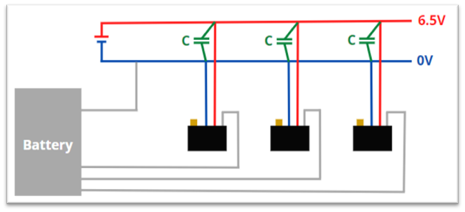

Figure 20.1

Thus, I had time to finish all the connections of the servomotors as can be seen in figure 20.2.1 and 20.2.2

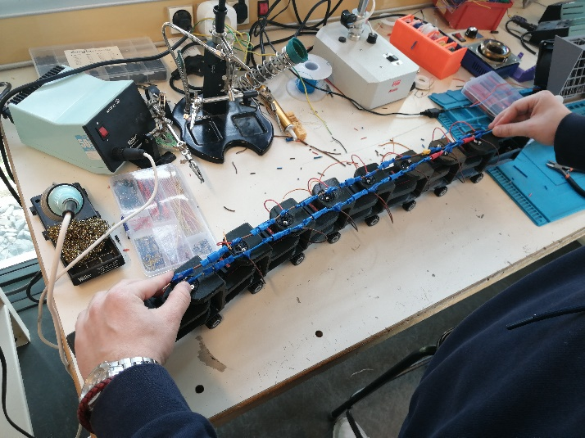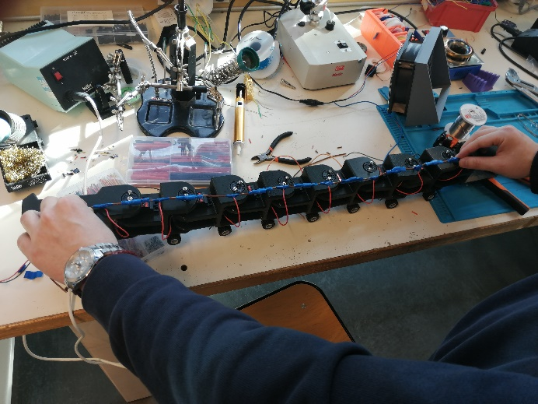

Figure 20.2.1

Figure 20.2.2

During the next sessions, I will determine the capacitor adapted to our project. To do this, knowing that the calculation method gives us inconsistent results, I will test different types of capacitors until I find the one that suits and that best limits the voltage drops of the project.